- Log into MyWorkDay
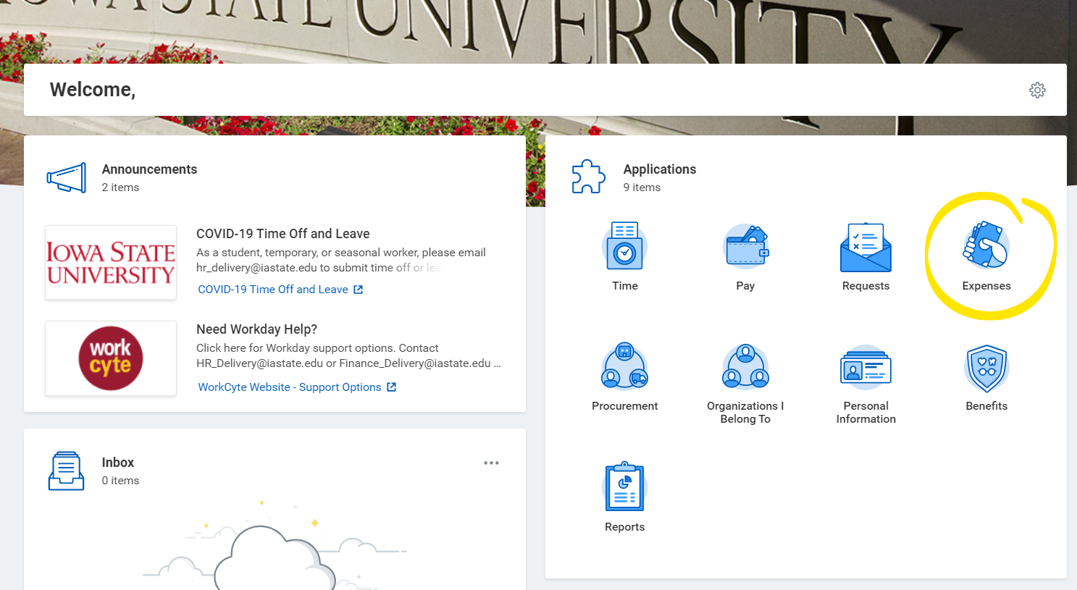
- Click on Expenses (highlighted below)
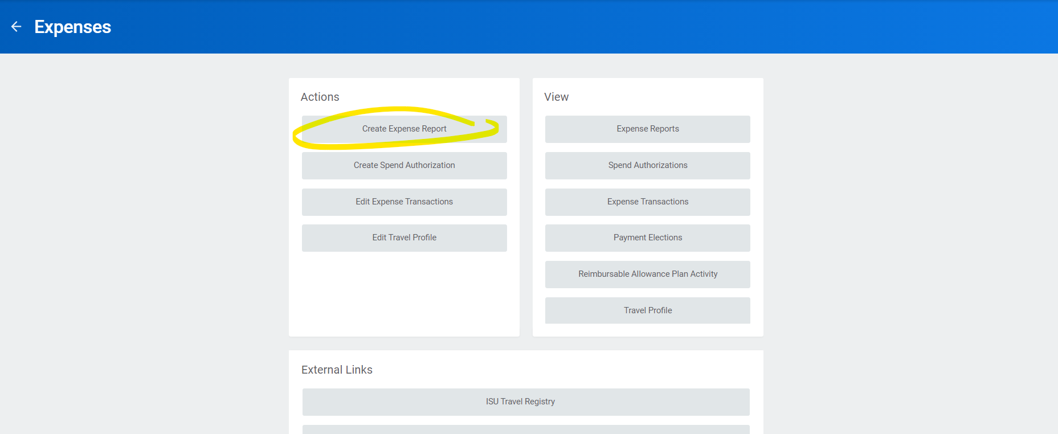
- Click “Create Expense Report”
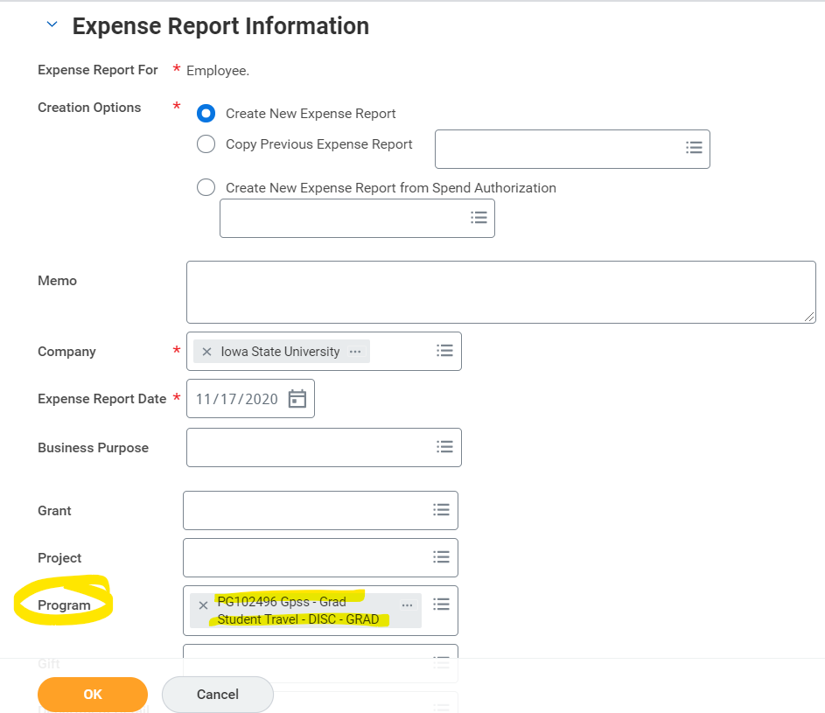
- Once you are in that form, make sure to add “PG102496” to the Program portion of the Expense report and continue filling out the form!

